Table of Contents
Introduction 1
Component 1
JSX 1
useState 1
App Function / Method 1
Forms of a Component 1
Responsibilities of React Components 1
Libraries Involved 2
React Library 2
ReactDOM Library 2
Install REACT 2
Creating a REACT Project 3
Dependencies Created after Generating a New REACT Project 3
Run REACT Project 3
Import Vs. Require 4
Create a Starting Index.js 4
Semantic UI 8
Using CDN: 8
Generate Massive Amounts of Fake Data using Faker.js 9
Creating and Using the New Component 9
Props (Properties) System 10
Functional Components 13
Class Components 14
State System 15
Ways in Initializing the State Object 17
The Component Lifecycle 19
Lifecycle Methods 19
Seasons React Project 20

Introduction

Component
A Component is one of the core building blocks of React. In other words, we can say that every application you will develop in React will be made up of pieces called components. Components in React basically return a piece of JSX code that tells what should be rendered on the screen.

JSX
JSX is basically a set of instructions to tell React what content we want to show on the screen at any given time. JSX Elements consists of ordinary DOM elements and/or other Components. React will walk through each content line and identify if it is an ordinary DOM Element or is it a React Component. If it is a React Component, React is going to call that Component function and inspect all the JSX that it gets back.

useState
A function we use to work with a system in React called “State System.” The State system is all about managing (or keeping track) data inside the application that changes through time (due to user interaction).
In general, we use the State system to somehow get React to update the HTML in the application.

App Function / Method
Is a React component because it is a plain JavaScript function that returns some JSX.

Forms of a Component
- Function-based Components
- Class-based Components

Responsibilities of React Components
- Produce JSX that will tell React what we want to show in the screen to the user.
- Handles User Events (feedback) such as user typing into a text input or clicking on a button.
All components created are going to be functions that return JSX.

Libraries Involved

React Library
- Known as the “Reconciler”
- Has a bunch of code inside of it that knows how to get a bunch of different components to work together. Such as how to call a component function, how to get back the JSX, and how to decide whether to create another HTML element or to call another component function.

ReactDOM Library
- Known as the “Reconciler” – Responsible for showing/rendering content to the user.
- Knows how to take a set of instructions on different elements we need to create and produce an HTML out of it.
- Basically takes all of that JSX and turns it into actual HTML and puts all that HTML into DOM and show it to the user.

Install REACT
$ npm install –g create-react-app
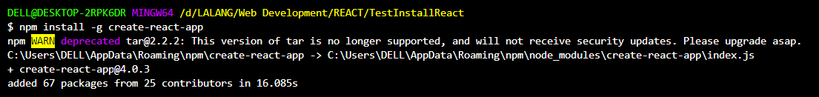
npm Run NPM (Node Package Manager). NPMs are used to install tons of open-source javascript packages to your local computer to power the project you are putting together. We reached out to NPM to download the package called create-react-app and install it in our local computer.
install The NPM command/program has many subprograms associated with it. “install” is a sub-command of NPM. We want to install the package to our local computer.
–g “–g” (g-flag) indicates that we want to install this package globally on our computer so we can run it on our terminal.
create-react-app
The name of the package we want to install.

Creating a REACT Project
Long Way:
$ npm install –g create-react-app
$ create-react-app <name of REACT project>
Short Way:
$ npx create-react-app <name of REACT project>
This technically installs create-react-app package and then create a REACT project.
Only works for NPM version 5.2 and higher.

Dependencies Created after Generating a New REACT Project
Babel (babeljs.io)
- A command-line tool that can take any version of JavaScript and spit out another newer or older version of JavaScript code that will safely execute in the browser.
- Internally Babel consists of a tremendous number of packages so it partially explains why there are a 1k+ packages when generating a new REACT project.

Run REACT Project
$ cd <inside your REACT Project directory>
$ npm start

Visit localhost:3000 and make sure you can see the default program of create-react-app
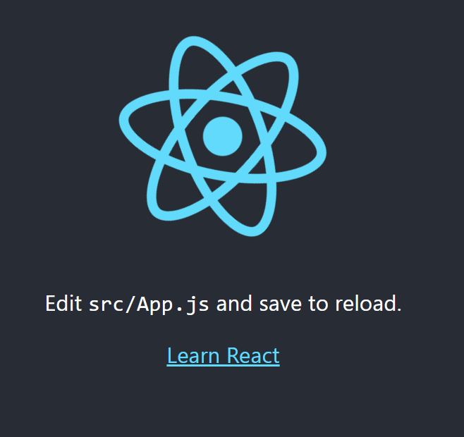

Import Vs. Require
These 2 are essentially just using different Module Systems. Each Module Systems have a different set of rules that govern the syntax.

Import Statement
- References to a Module System called ES2015 Modules (ES6).
- This Module System is essentially a set of rules that describes how code can be shared between different JavaScript files.

Require Statement
- References to a Module System called CommonJS Modules.
- CommonJS Modules is a different set of rules that also governs how to share code between different JS files.

Create a Starting Index.js
- Import React and ReactDOM Libraries.
//Import REACT and REACTDOM libraries
import React from "react";
import ReactDOM from "react-dom";
import Tells JavaScript that we want to get code from either a dependency, code from another file we created, or another package installed inside the project.
React The variable we want to assign the imported code. This could be named anything but by convention it is named after the library itself.
from Pulls the code from the library or file we are importing from.
react All the “react” library’s code will be taken and assigned to the variable declared, mainly, the “React” variable earlier.

- Create a React Component.
//Example of a Function-based Component.
const App = ()=>{
//Looks like HTML elements but are not. This is JSX Code.
return <div> Hi there! </div>;
}

- Display the React Component.
//Display the REACT component
ReactDOM.render(
<App />,
/*
By convention in create-react-app generated application, the component (App) will be rendered inside
the index.html's <div> tags with an ID of "root".
*/
document.querySelector("#root") // Built-in native function that's available in all Browsers
);

JSX
JSX is a special dialect of JS. It is not HTML but is very similar in form and function but with a couple of differences.
Browsers do not understand JSX that is why we use tools such as Babel to turn it into normal JS.
Babel converts JSX code into JavaScript function call – React.createElement – that renders your JSX for you in ES5 format which is the format supported by all browsers.
Site: babeljs.io
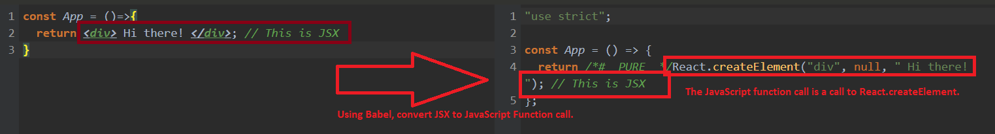

JSX Vs. HTML
const App = ()=>{
return ( //Multi-line JSX code needs an opening parenthesis at the same line of the return keyword.
//Add an indention then your JSX Code.
<div>
<label class="label" for="name">Enter Name: </label>
<input id="name" />
<button style="background-color: green; color: white;">Submit</button>
</div>
);
}

The Error:
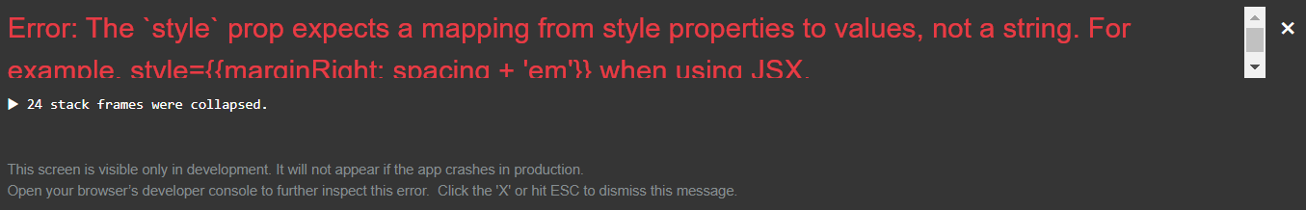

- Adding custom styling to an element in JSX uses a different syntax.
HTML Element:
<button style="background-color: green; color: white;">Submit</button>

JSX:
<button style={{backgroundColor: ‘green’, color: ‘white’}}>Submit</button>
{ Indicates that we want to reference a JS variable inside our JSX.
{ Indicate that the style properties within the parenthesis is to be treated as a JS object.
Whenever a style property is in compound form (such as background-color), combine it and capitalize the first letter of the second word.
Ex: background-color backgroundColor
By convention in the JavaScript community, JSX properties uses double quotes ( “ ) to indicate a string. For non-JSX properties, use single quote ( ‘ ).

- Adding a class to an element in JSX uses a different syntax.
HTML Element:
<label class="label" for="name">Enter Name: </label>
JSX:
<label className="label" htmlFor="name">Enter Name: </label>
JSX has already a keyword called class which declares a class component.
But JSX already is intelligent enough to differentiate between a class declaration and a class attribute, therefore, causing no build error. Yet it is good practice to clearly differentiate the two.

- JSX can reference JS variables.
HTML Element:
<button style="background-color: green; color: white;">Submit</button>
JSX:
const buttonText = "Click Me!";
<button style={{backgroundColor: ‘green’, color: ‘white’}}>{buttonText}</button>
{ Indicates that we want to reference a JS variable/function that returns a type of value that is compatible with the JSX syntax inside JSX.
Restrictions:
React does not allow a JS object and reference it inside of JSX as a string.
Example:
const buttonText = { text: “Click me!” };
const style = {
backgroundColor: "green",
color: "white"
};
Error:
<button style={{backgroundColor: ‘green’, color: ‘white’}}>{buttonText}</button>
Fix:
<button style={ style }>{buttonText.text}</button>

Sample Code:
const App = ()=>{
const buttonText = "Click Me!";
const style = {
backgroundColor: "green",
color: "white"
};

return ( //Multi-line JSX code needs an opening parenthesis at the same line of the return
keyword.
//Add an indention then your JSX Code.
<div>
<label className="label" htmlFor="name">Enter Name: </label>
<input id="name" />
<button style={style}>{buttonText}</button>
</div>
);
}

3 Tenets of the React Ecosystem:
- Component Nesting – a component used inside another component.
- Component Reusability – creating components that can be easily reused throughout the application.
- Component Configuration – the component must easily be configured after being created.

Semantic UI
An open-source styling CSS framework.
Link: https://semantic-ui.com/
Install: https://semantic-ui.com/introduction/getting-started.html or Using CDN (easier way)

Using CDN:
- Search for Semantic-UI CDN ( Link: https://cdnjs.com/libraries/semantic-ui )
- In the site, search for the latest AJAX Library of semantic.min.css and copy the link.
Copied Link: https://cdnjs.cloudflare.com/ajax/libs/semantic-ui/2.4.1/semantic.min.css
- Add the copied link to your stylesheet in your index.html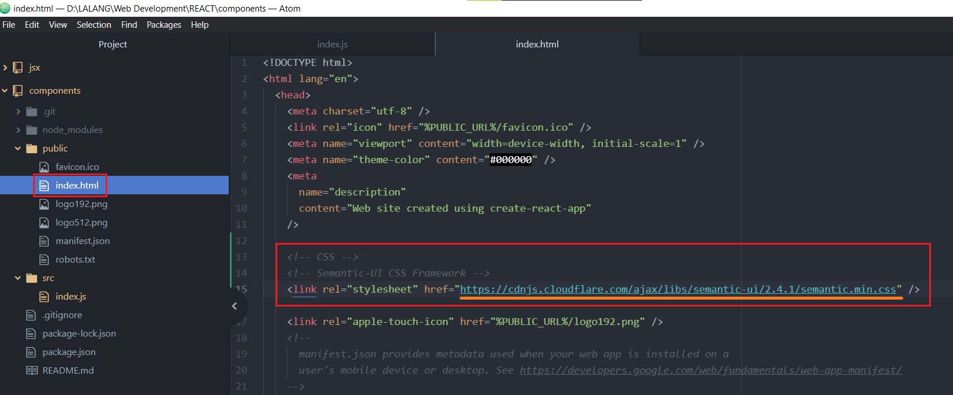

To check if Semantic-UI has successfully updated your application, go to your application > inspect > Network > CSS > Refresh (to let semantic.min.css appear)
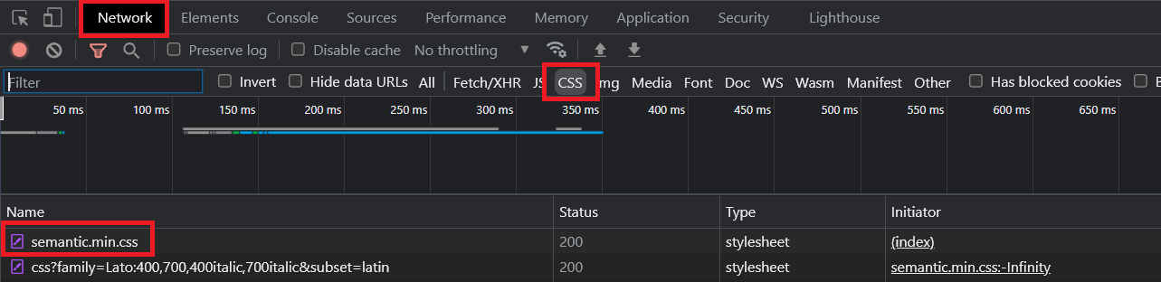

Generate Massive Amounts of Fake Data using Faker.js
Link: https://github.com/marak/Faker.js/
Install (using the terminal):
$ npm install –-save faker
–-save Save faker to our local project.

Use the “import” keyword to your project whenever we want to use some code from another file or open-source project or dependency.
import faker from "faker";

Creating and Using the New Component
- Component name must be named with a format of camel casing with each word starting with a capital letter.
- Create a new JS file following the exact name of the new Component.
- Import React in the new JS Component file.
- Create your Component along with its JSX code.
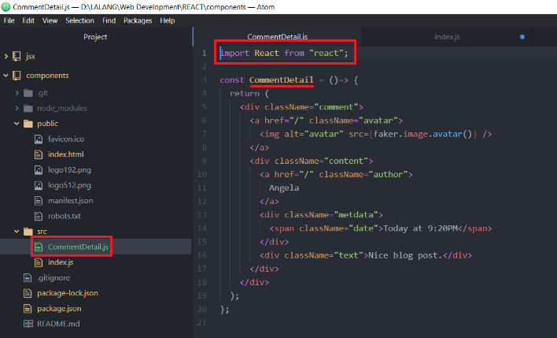
- Make your component accessible to the rest of your project by adding this code at the end of the component file:
export default <ComponentName>;
- In your main/index.js file, import your Component
import <ComponentName> from "./<ComponentName>"
"./" means look at the same folder the source file is currently in.
No .JS extension is needed since Web Pack (the library doing the importing stuff and tying all these different files together) is going to automatically attempt to find files ending in .JS for the user.
- Add the new imported Component to your App() Component as a JSX tag.
You must treat your Component as a JSX tag.
import CommentDetail from "./CommentDetail"

const App = ()=> {
return (
<div className="ui container comments">
<CommentDetail />
</div>
);
};

Props (Properties) System
Is a system for passing data from a Parent Component to a Child/Nested Component.
Goal is to communicate data from the parent down to the child with the intent of customizing the child and making sure it displays and behaves the way it needs to when the User interacts with it.
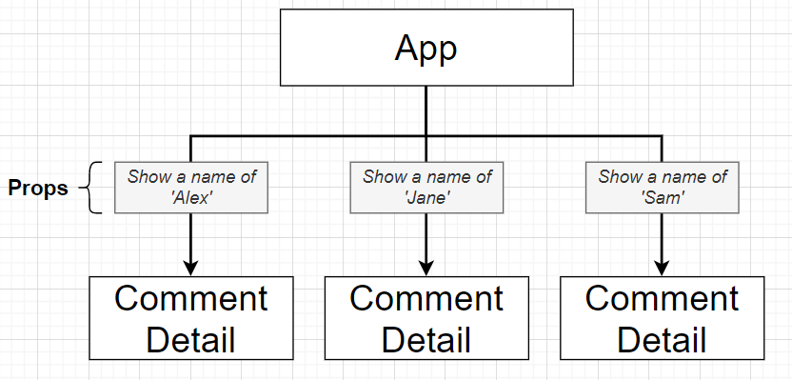

- Index.js
- import React from "react";
- import ReactDOM from "react-dom";

- // Import from Components created.
- import CommentDetail from "./CommentDetail"

- const App = ()=> {
- return (
- <div className="ui container comments">
- <CommentDetail author="Angela"/>
- <CommentDetail author="Carole"/>
- <CommentDetail author="Bezalel"/>
- </div>
- );
- };
- CommentDetail.js
- import React from "react";
- import faker from "faker";

- const CommentDetail = (props)=> {
- console.log("Props: ", props);

- return (
- <div className="comment">
- <a href="/" className="avatar">
- <img alt="avatar" src={faker.image.avatar()} />
- </a>
- <div className="content">
- <a href="/" className="author">
- {props.author}
- </a>
- <div className="metdata">
- <span className="date">Today at 9:20PM</span>
- </div>
- <div className="text">Nice blog post.</div>
- </div>
- </div>
- );
- };

- // This line makes this component available and accessible to the rest of the project.
- export default CommentDetail;
Line 5: Console logging props parameter. Props is a JavaScript Object that contains all the information passed from the parent to the child.
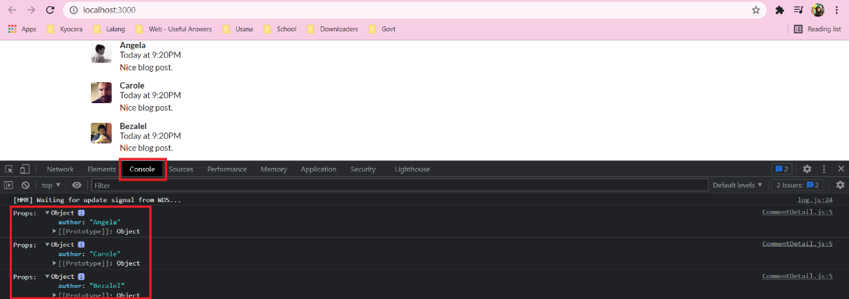
Sample 1:
Using the ApprovalCard Component
<ApprovalCard />
<CommentDetail
author="Angela"
timeAgo="Today at 4:17 PM"
comment="I hate studying but I need to!"
image={faker.image.avatar()}
/>
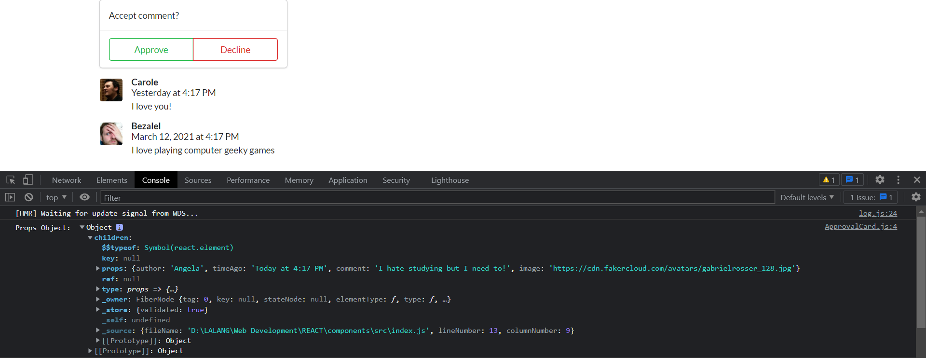

Sample 2:
Using the ApprovalCard Component as the parent component and adding CommentDetail Component as its child component.
Basically when passing from one component to another, a child component [CommentDetail] will show up inside of the ApprovalCard’s props object. Specifically on the property of props object’s children’s property.

<ApprovalCard>
<CommentDetail
author="Angela"
timeAgo="Today at 4:17 PM"
comment="I hate studying but I need to!"
image={faker.image.avatar()}
/>
</ApprovalCard>

The ApprovalCard Component uses the child component [CommentDetail] as a prop.
const ApprovalCard = (props) => {
console.log("Props Object: ", props)
return (
<div className="ui cards">
<div className="card">
<div className="content">{props.children}</div>

<div className="extra content">
<div className="ui two buttons">
<div className="ui basic green button">Approve</div>
<div className="ui basic red button">Decline</div>
</div>
</div>

</div>
</div>
);
};
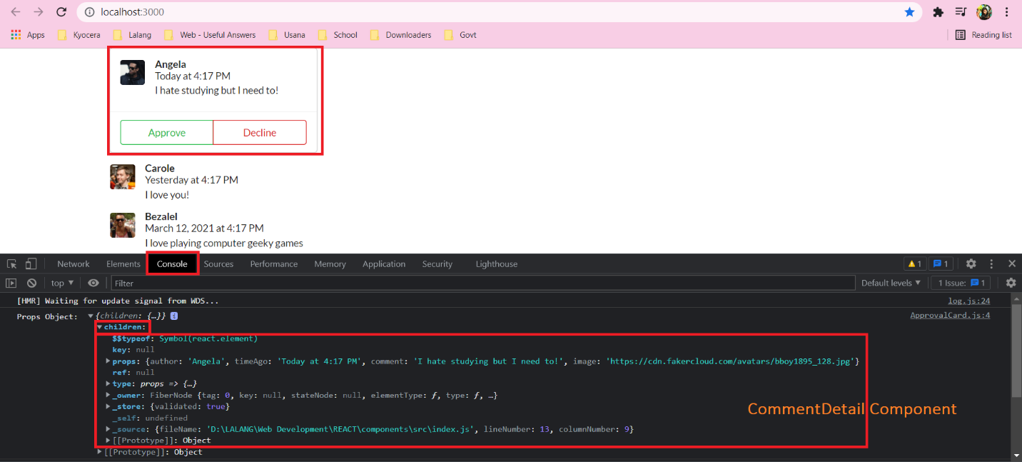

Functional Components
Using a Functional Component:
- JS file loaded by browser
- App Component gets created
- Calls geolocation service (takes a lot of time 3-5 seconds)
- App returns JSX and gets rendered to page as HTML
- … waiting …
- Get the result of geolocation
- const App = ()=>{
- window.navigator.geolocation.getCurrentPosition(
- position => console.log("Successful Callback: ", position),
- err => console.log("Failure Callback: ", err)
- );
- return <div> Latitude: </div>;
- };
The problem with Functional Component is that it cannot wait for GeoLocation Services (Line 3 or Line 4) to finish executing before returning the JSX to be rendered as HTML. Instead, it starts the execution of Line 2 and directly proceeds with Line 6. By the time JSX is rendered to the Web Page, Line 3 or Line 4 may or may not have finished executing yet so the solution for this issue is using Class Components.

Class Components
Using a Class Component:
- JS file loaded by browser
- App Component gets created
- Calls geolocation service (takes a lot of time 3-5 seconds)
- App returns JSX and gets rendered to page as HTML
- … waiting …
- Get the result of geolocation
- Tell the component to re-render itself along with the new information (from Step 6).

Rules of Class Components:
- Must be a JavaScript Class
- Must extend (subclass) React.Component
- Must define a “render” method that returns some amount of JSX.

Benefits of Class Components
- Easier code organization
- Can use State (another React System) making it easier to handle user inputs such as data-loading events.
- Understands the Lifecycle Events making it easier to do things when the App first starts.

- class App extends React.Component {
- render() {
- window.navigator.geolocation.getCurrentPosition(
- position => console.log("Successful Callback: ", position),
- err => console.log("Failure Callback: ", err)
- );
- return <div>Latitude: </div>
- }
- };
class App extends React.Component
class When creating a class, we are creating a class in JavaScript that only has one method assigned to it – the render() method. In order to use a Class-based Component React, React expects our Class-based Component to have many other methods attached to it. Instead, we borrow all the other methods from other class called React.Component using extends
extends Allows us to pull a ton of built-in functionality from the class (React.Component) to our own created class. Just borrowing some functionalities from React.Component to our App class.
React.Component
The React Class that will be used by App Class to borrow functionalities from .

State System
Rules of the State System:
    - Only usable with Class Components. For Functional Components, the “Hooks” System must be used.
    - You will confuse props with State.
    - “State” is a JS object that contains data relevant to a Component.
    - Updating “State” on a Component causes the Component to (almost) instantly re-render.
    - State must be initialized when a Component is created.
    - State can only be updated using the function “setState()”.

- import React from "react";
- import ReactDOM from "react-dom";

- // "extends" --> borrowing functions from class React.Component
- class App extends React.Component {
- /*
- A function from the JavaScript language and not particular to React.
- Called everytime an instance of this class is created.
- The reason why we're creating the constructor() is so we can initialize the state object.
- */
- constructor(props) {
- /*
- REQUIRED:
- React.Component has its own constructor() that setups all the code for the class.
- But with App class' constructor, it will override React.Component's existing one.
- By calling "super" it references and calls to the parent's (React.Component) constructor
- function.
- */
- super(props);

- /*
- THE STATE OBJECT
- Initialize the state object by creating a JS object ( {...} ), assigning a property/key-
- value pair to the object, and assigning it to the state.
- This will be the only time we'll be doing direct assignment to this.state.
- */
- this.state = { lat: null, errorMessage: "" };

- /*
- Place this geolocation api here since render() will be called a lot of times.
- */
- window.navigator.geolocation.getCurrentPosition(
- (position) => {
- console.log("Success Callback: ", position);
- /*
- setState() is a React.Component function that is used to change the value of the State Object

- // DON'T DO THIS (direct assignment to state object)
- this.state.lat = position.coords.latitude;
- */
- this.setState({ lat: position.coords.latitude });
- },
- (err) => {
- console.log("Failure Callback", err);
- this.setState({ errorMessage: err.message });
- }
- );
- }

- // React requires render() for this component to work.
- render() {
- // Conditionally rendering content
- if (this.state.lat && !this.state.errorMessage) {
- return <div>Latitude: {this.state.lat}</div>;
- }

- if (!this.state.lat && this.state.errorMessage) {
- return <div>Error: {this.state.errorMessage}</div>;
- }

- return <div>Loading!!!</div>;
- }
- }

- ReactDOM.render(<App />, document.querySelector("#root"));
Excerpt from the React Documents:
State is a reference to the component state at the time the change is being applied. It should not be directly mutated (Line 27).
Never mutate this.state directly (Line 41, Line 45), as calling setState() afterwards may replace the mutation you made. Treat this.state as if it were immutable.

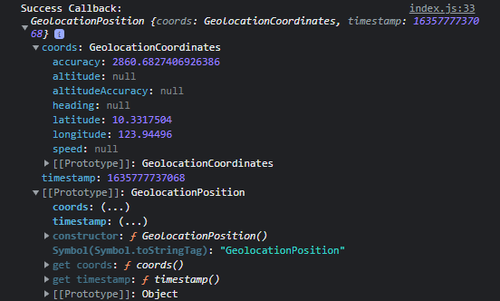
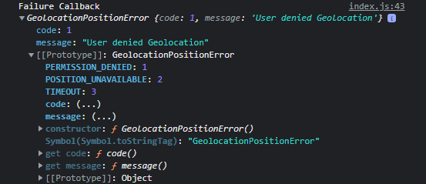

Ways in Initializing the State Object
First Way: Traditional / Old Way
Initializing the State Object inside a constructor function.
class App extends React.Component {
constructor(props) {
super(props);
this.state = {lat:null};
}
}

When Babel (a JS transpiler) converts this code to plain old ES5 JavaScript that can run in any browser, there is not much difference from this style of initializing from the ES5 style.
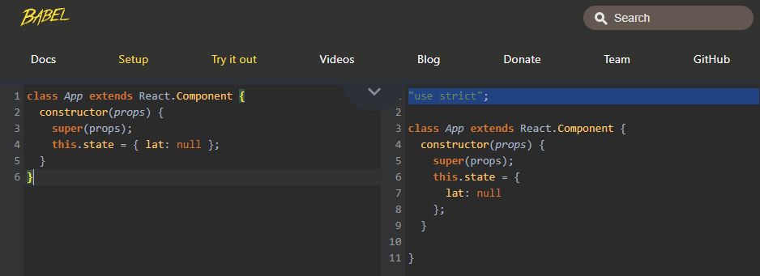

Second Way: Initializing State as an instance property.
Omitting the constructor function and the this keyword when initializing the State Object.
Using this style can save your code some lines and makes your Component a little bit easier to read.
class App extends React.Component {
state = { lat: null };
}
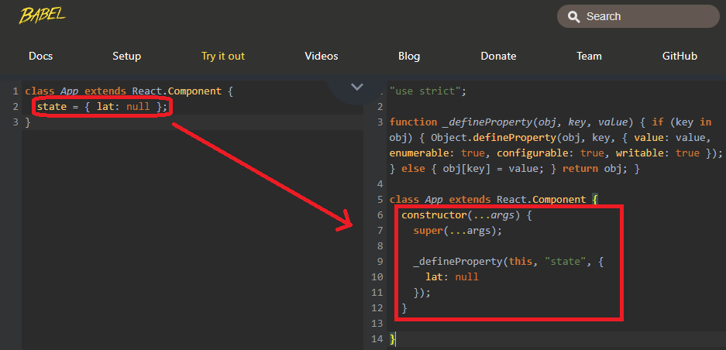

The Component Lifecycle
Is a function we can optionally define inside of our Class-based Components. If we decide to implement these methods, they’ll be called automatically by React at certain points during a Component’s Lifecycle.
A Component created, showed up in DOM/browser, may call setState() causing the Component to re-render, lastly, at some point in time a Component will be removed and will stop showing its content on the browser.

Lifecycle Methods
Are functions that are called during distinct/discreet times during the Cycle.
  - constructor *
- If defined, this function will automatically be called when a new instance of the Component is created.
- Good place to do one time setup (initializing the State Object) and initial data loading (network request to some outside API).
  - render
- Not optional. Only method that we must define.
- Technically a Lifecycle function. It gets at some point during the Lifecycle of the Component.
- Then returns some amount of JSX and that content becomes visible on the screen.
- Avoid doing anything besides returning JSX.
  - componentDidMount *
- Immediately after some content has been visible on the browser, this method is called.
- This method will automatically be called one time when our Component first gets rendered on the screen.
- A good place to put some amount of code for setup, initial data loading(network request to some outside API), or a wide variety of different operations we might want to execute one time.
- Between the constructor and this method, it is good practice to move all initial data loading in this function instead of in the constructor.
- After this method is called, our Component basically sits and waits for updates. An update will come in the form of a setState(). Every time we call setState() and update our state, our Component will re-render/update itself.
  - componentDidUpdate *
- Called every time our Component updates itself. render is first called then this function.
- An update will come in the form of a setState(). Every time we call setState() and update our state, our Component will re-render/update itself.
- Good place to do more data-loading when State/props change.
Example: Network request whenever a user clicks on a button, new props from a parent Component, or every single time they enter a text in an input.
  - componentWillUnmount *
- Called when we decide to stop showing our Component.
- Used every time we remove a Component on screen, and we need to do some cleanup after it.
- Good place to do cleanup especially for non-React libraries.
Example: Using Google Maps inside a React Application.
Other Lifecycle Methods (rarely used):
  - shouldComponentUpdate *
  - getDerivedStateFromProps *
  - getSnapshotBeforeUpdate *
* - A function we can optionally define.

Seasons React Project
- INDEX.JS
- import React from "react";
- import ReactDOM from "react-dom";
- import SeasonDisplay from "./SeasonDisplay";
- import Loader from "./Loader";

- // "extends" --> borrowing functions from class React.Component
- class App extends React.Component {
- state = { lat: null, errorMessage: "" };

- componentDidMount() {
- /*
- Place this geolocation api to practice data-loading in this method.
- */
- window.navigator.geolocation.getCurrentPosition(
- (position) => this.setState({ lat: position.coords.latitude }),
- (err) => this.setState({ errorMessage: err.message })
- );
- }

- /*
- HELPER METHOD/FUNCTION
- Instead of putting your logic in render(), place it in a helper method instead to keep your code organized.
- */
- renderContent() {
- // Conditionally rendering content
- if (this.state.lat && !this.state.errorMessage) {
- return <SeasonDisplay lat={this.state.lat} />;
- }

- if (!this.state.lat && this.state.errorMessage) {
- return <div>Error: {this.state.errorMessage}</div>;
- }

- return <Loader message="Please accept location request..." />;
- }

- // React requires render() for this component to work.
- render() {
- return <div>{this.renderContent()}</div>;
- }
- }

- ReactDOM.render(<App />, document.querySelector("#root"));
- SeasonDisplay.js
- /*
- Importing a CSS file exclusive for SeasonDisplay Component
- Adding a CSS file into a JavaScript file does not mean all the CSS classes are loaded up upon import.
- WebPack (essentially takes all these different files and joins them together), is going to stick this
- .css specified file and stick it in the header section of the index.html file.
- */
- import "./SeasonDisplay.css";
- import React from "react";

- const seasonConfig = {
- Winter: {
- text: "Burr, it's chilly.",
- iconName: "snowflake",
- },
- Summer: {
- text: "Let's hit the beach.",
- iconName: "sun",
- },
- };

- const getSeason = (lat, month) => {
- if (month > 2 && month < 9) {
- return lat > 0 ? "Winter" : "Summer";
- } else {
- return lat < 0 ? "Summer" : "Winter";
- }
- };

- const SeasonDisplay = (props) => {
- console.log("Season Display [props]: ", props);
- const season = getSeason(props.lat, new Date().getMonth());
- // De-structuring the seasonConfig object
- const { text, iconName } = seasonConfig[season];

- return (
- <div>
- <div className={`season-display ${season}`}>
- <i className={`icon-topLeft ${iconName} massive loading icon`} />
- <h1>{text}</h1>
- <i className={`icon-bottomRight ${iconName} massive loading icon`} />
- </div>
- </div>
- );
- };

- export default SeasonDisplay;
- SeasonDisplay.css
- .icon-topLeft {
- position: absolute;
- top: 10px;
- left: 10px;
- }

- .icon-bottomRight {
- position: absolute;
- right: 10px;
- bottom: 10px;
- }

- /* Find an element that has a Class element of season-display and Winter with an i(icon) child element */
- .season-display.Winter i {
- color: blue;
- }
- .season-display.Summer i {
- color: orangered;
- }

- .season-display {
- display: flex;
- justify-content: center;
- align-items: center;
- height: 100vh;
- }

- .Winter {
- background-color: aliceblue;
- }

- .Summer {
- background-color: orange;
- }

- Loader.js
- import React from "react";

- const Loader = (props) => {
- return (
- <div class="ui active dimmer">
- <div class="ui text loader">{props.message}</div>
- </div>
- );
- };

- /*
- Object that provides default properties to this Component.
- If some of props properties are not provided, this Object provide alternate values.
- */
- Loader.defaultProps = {
- message: "Loading...",
- };

- export default Loader;

Handling User Inputs with Forms and Events

Event Handler
- SearchBar.js
- import React from "react";

- class SearchBar extends React.Component {
- onInputChange(event) {
- // Contains the text the user just added in the input element.
- console.log(event.target.value);
- }

- render() {
- return (
- <div className="ui segment">
- <form className="ui form">
- <div className="field">
- <label>Image Search: </label>
- <input type="text" onChange={this.onInputChange} />
- </div>
- </form>
- </div>
- );
- }
- }

- export default SearchBar;
<input type="text" onChange={this.onInputChange} />
onChange Is an HTML event indicating an HTML element has been changed.
JavaScript lets you execute code when events are detected. HTML allows event handler attributes, with JavaScript code, to be added to HTML elements.
onInputChange (user defined callback function)
When passing a callback function (onInputChange) to the prop (onChange), we don't add a set of parentheses because if we did, this method will automatically execute every time your Component is rendered.
By removing the parenthesis, we are passing a reference of the function onInputChange to the input element so the input element can call this function in some point of time in the future.
Again, whenever we pass a callback function (onInputChange) to any event handler (onChange) we do not add parenthesis.
The callback function will have a parameter, called event, that's automatically passed to it and is a normal JS object that contains information about the event that just occurred.

onInputChange(event) {
// Contains the text the user just added in the input element.
console.log(event.target.value);
}

Callback Function Naming Convention
on
+ <name of the element we are assigning this callback to>
+ <name of the event we are watching for>
on + Input + Change onInputChange()

dsfdsaf

